ZAPATISTA REBELLION IN MEXICO

In 1994, a new rebellion started in the Mexican state of Chiapas. Chiapas is a state in southern Mexico, close to Guatemala. This region of Mexico is made up of many poor farmers.
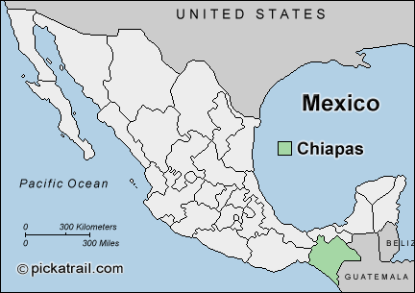
In 1994, a group of Mexicans in Chiapas who were Native Americans started a rebellion against the Mexican government. The rebels called themselves the Zapatista National Liberation Army or Zapatistas. The group was named for Emiliana Zapata, who was a farmer and leader of the 1910 Mexican Revolution.

The Zapatistas used guerilla warfare against their enemies instead of traditional fighting. Guerilla warfare is when a small group of fighters use surprise attacks to defeat a stronger force. The Zapatistas would launch surprise attacks on their enemy before retreating and waiting to attack again.

The Zapatistas protested the poverty faced by Native Americans and other farmers in that region of Mexico. The Native Americans in Mexico generally lived in very bad conditions, received poor education, and had limited access to health care.

Native American farmers in Chiapas were also upset because of the changes the government made in laws about land ownership. After the Mexican Revolution, the constitution granted land to people, no matter how poor they were. The government was changing those laws and the poor farmers were losing their land!

The Zapatistas began their revolt on January 1, 1994…just hours after a new trade agreement between Mexico, Canada, and the United States began. The North American Free Trade Agreement (NAFTA) eliminated trade barriers and tariffs between the three countries. Tariffs are taxes on goods brought into a country.

The poor Mexican farmers did not like NAFTA, because it would make it easier for cheap crops to be brought from the United States and sold in Mexico. If cheaper products were brought from Mexico, the Mexican farmers would have to decrease the amount they sold their crops for. The Mexican farmers would lose even more money!

The Zapatistas seized control of four major towns in Chiapas. More than 100 people were killed in the fighting between the rebels and government troops. The government eventually regained control and called for an end to the fighting. Negotiations began between the rebels and the government, forcing the government to look at the Native Americans’ concerns.

The Zapatista guerilla movement had a significant impact. Several political reforms were put into place to improve the lives of Native Americans in Mexico. The Mexican government made improvements in basic things like housing, education, division of land, and laws ensuring that Native Americans were represented in the national legislature.

What is Chiapas?
What is the Zapatista National Liberation Army?

ZAPATISTA
GUERILLA
MOVEMENT
Vocabulary
- Guerilla Warfare:

- Tariffs:

- NAFTA:
What impact did the Zapatistas have on Mexico?
What is NAFTA and why were the Zapatistas against it?
What were the Zapatistas fighting against? (What were they mad about?)

