Causes of World War I

“The Great War”
World War I, 1914 – 1918

In _____, World War I started in Europe. It began as a conflict between the countries of Austria-Hungary and Serbia, but quickly turned into a global war between __ countries.
- From July 1914 to November 1918
- 22 million people (soldiers and civilians died)
- Also called the “Great War” or the “___________________________________________”
_______________, Alliances, Imperialism, and Nationalism (MAIN) set the stage for a war.
- One event was all that it took to start a war…it was a “________________________” ready to explode
…what happened to start World War I?

Assassination of Archduke Franz Ferdinand
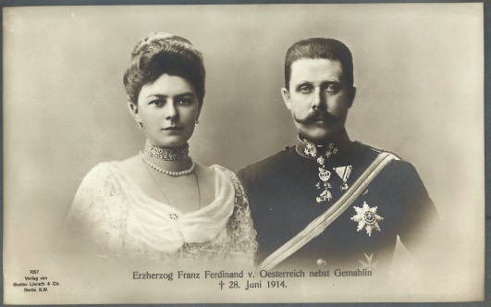
Archduke Franz _______________________
- Prince of _________________-Hungary
  - His country ruled over Serbia as part of its empire
- In the summer of 1914, Franz Ferdinand and his wife, Sophie travelled to _______________

On June 28, 1914, Franz Ferdinand and his wife were assassinated in Sarajevo, Serbia
- ___________________: a sudden or secret attack that kills someone of importance
- Members of a Serbian nationalistic group called the “______________________” planned the assassination

The assassination started a “Domino Effect” of disputes and reactions, shattering world peace

Road to War…
Following the assassination, Austria-Hungary demanded action be taken against Serbia and countries took side based on __________________________
- When no agreement was made, countries took sides to go to war
  - Germany and __________________ were allies with Austria-Hungary
  - France, ________________, and Great Britain (UK) wanted to defend Serbia
- In 1917, the United States joined the war after Germany sunk their passenger ship, the Lusitania

Allied Powers/Triple Alliance  - Great Britain (UK)  - France  - Russia | Central Powers/Triple Entente  - Germany  - Italy  - Austria-Hungary

World War I was different from other wars previously fought by Europeans

- New Technology
  - Machine guns
  - Poisonous __________
  - _____________
  - Airplanes

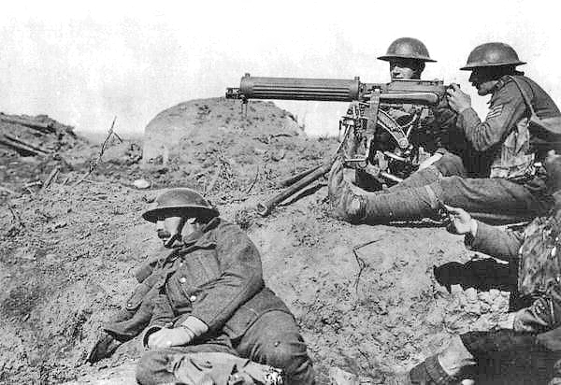
- War of _____________________: war strategy where victory is based on killing more enemy soldiers and destroying more enemy supplies
  - Goal is to completely deplete enemies resources (soldiers and supplies)

- ________________ Warfare: a type of warfare where soldiers dig trenches to live in and attack over an open area
  - Very deadly, but little change/movement
  - “__________________________”: area between the two enemy trenches

On ___________ 28, 1914, Austria-Hungary invaded Serbia, causing Russia and Germany to mobilize their armies
- Germany invaded _________________ to advance towards France (Schlieffen Plan)
  - This caused Great Britain (UK) to declare war on ____________________
- Germany advanced towards Paris, but was stopped in eastern France
  - The armies dug _____________________, making the “Western Front”
- Eastern Front: battle front in eastern Europe where Russians fought against the __________________ Powers (Germany, Austria-Hungary, and Italy)

End of World War I
“The War to End All Wars” came to an end in _______________________ 1918
- Officially ended on the 11th hour of the 11th day of November (11th month)
- Nations agreed to an ___________________, giving the victory to the _____________ Powers (UK, France, and USA)
  - Armistice: formal agreement for countries to stop fighting
  - _________ had withdrawn from the war in 1917 due to revolution at home

The Treaty of ___________________ was the official agreement to end World War I.
- After signing the treaty, Germany had to…
  - Accept complete blame/responsibility for the war
  - Pay ____________________ to the other countries for damages ($____billion)
  - Give up large parts of their territory and _____________________
  - Not have a ____________________
- The treaty made Germans very mad and resentful towards the other countries
  - It also caused economic problems for the country after the war ended

Russian Revolution

Summary: In 1917, there was a rebellion against the Russian government, causing the country to withdraw from World War I. Before the rebellion, Russia was an autocracy, meaning that there was only one ruler, who was called the “Czar”. After the Russian Revolution, a communist country called the Soviet Union was established and Vladimir Lenin was the ruler.

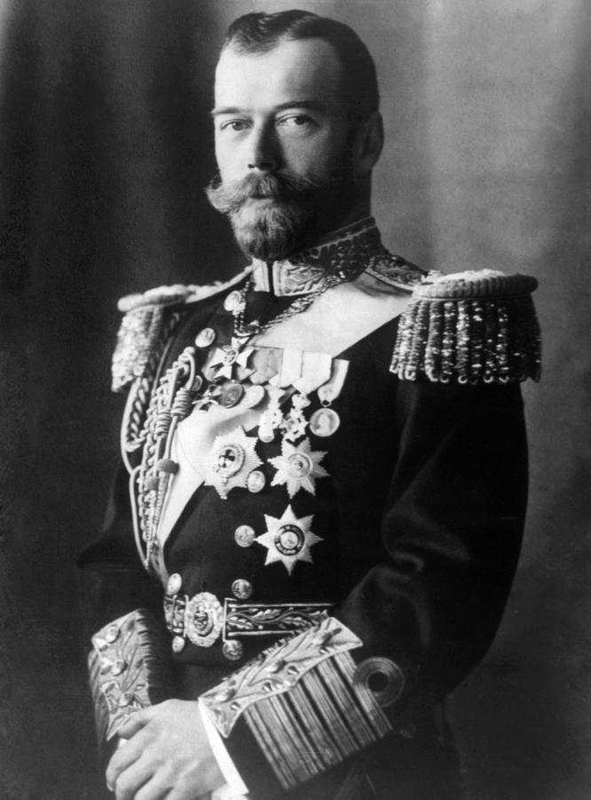 | Czar Nicholas II  In 1917, Nicholas II was the _____________ of Russia. He ascended to the throne in 1894 without realizing that he would be the last Czar of Russia.  - The ________________ family has ruled Russia as an autocracy for over 300 years.  Problems in Russia  During _____________________, Russia did not do well…  - Millions of soldiers were killed while citizens were starving from food ___________________  - Citizens were unhappy  - Russia seemed to be losing the war, because their soldiers were poorly _______________ and supplied
Riots in Russia
In early 1917, there were _____________ in the streets of Russia
- Citizens demanded change in the government and an end to the war

Czar _______________ II and his family were captured and _________________, while a temporary government was set up.

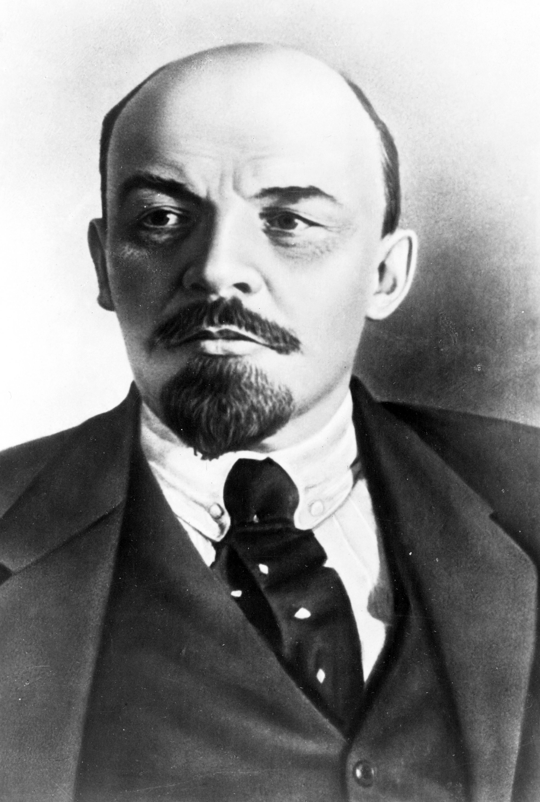 | End of the Czars  In 1918, Czar Nicholas II, his wife, and their 5 children were all ________________, ending the Romanov dynasty.  Establishment of the Soviet Union  After multiple rebellions and temporary governments, the ___________________________ was established in 1922.  - Communist government  - Led by Vladimir _______________

