Revolutionary Leaders of Latin America
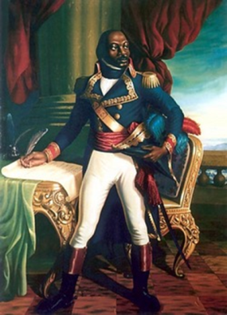  Toussaint L’Ouverture | - Where did Toussaint lead an independence movement?  - What is the country called today?  - What was Toussaint born as?  - Which country did he want independence from?  - What does “L’Ouverture” mean & why was it his nickname?  - When was he captured?  - When did the country finally gain independence?
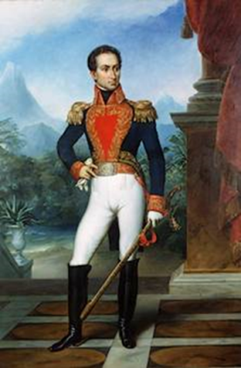  Simon  Bolivar | - Which European country did Bolivar fight against?  - Which countries did Bolivar help win independence?  - When and where was Bolivar born?  - Which country was named after Simon Bolivar?  - What is Bolivar’s nickname?  - What did he try to create after defeating the Spanish?
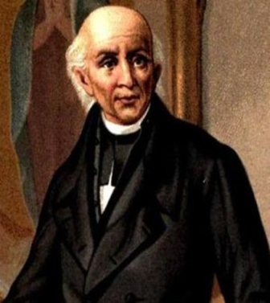  Miguel  Hidalgo | - Which country did Hidalgo help gain their independence?  - What is Miguel Hidalgo’s nickname?  - What was Hidalgo’s job?  - Which European country did Hidalgo fight against?  - Why did Hidalgo want his country to gain independence?  - What happened to Hidalgo in 1811?  - When did Mexico finally gain their independence?

