Name: ______________________________________ Class Period: ______

Geography Post-Test
STUDY GUIDE

Latin America
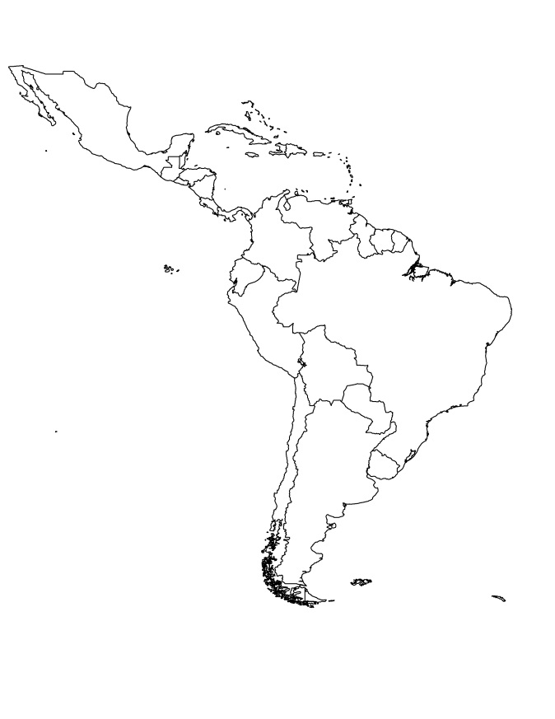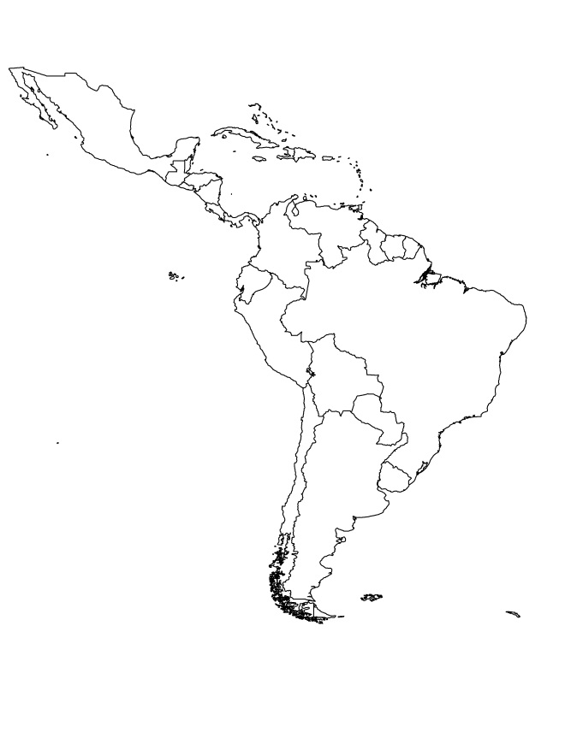

Label the countries of Latin America:
- Mexico
- Cuba
- Haiti
- Panama
- Bolivia
- Colombia
- Venezuela
- Brazil

Label the physical features of Latin America:
- Caribbean Sea
- Gulf of Mexico
- Panama Canal
- Amazon River
- Sierra Madre Mountains
- Andes Mountains
- Pacific Ocean
- Atlantic Ocean

Complete the chart below:
Country | Problem | Cause | Solution
Mexico
Brazil
Venezuela
Complete the chart below:
Country | Climate | Resources | Where People Live
Mexico
Cuba
Brazil
Venezuela

Answer the following questions:
- What are the 2 most common languages in Latin America?

- What is the main religion in Latin America?

- Why was the Panama Canal built?

- Why does Bolivia have a difficult time with trade?

Vocabulary:
- Literacy: _____________________________________________________________________ ______________________________________________________________________________

- Arable: _______________________________________________________________________ ______________________________________________________________________________

- Deforestation: ________________________________________________________________ ______________________________________________________________________________

- Smog: ________________________________________________________________________ ______________________________________________________________________________

- Mestizo: _____________________________________________________________________ ______________________________________________________________________________

- Mulatto: _____________________________________________________________________ ______________________________________________________________________________
Canada
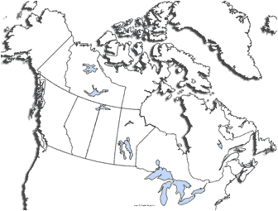
Label these features:
- Arctic Ocean
- Pacific Ocean
- Atlantic Ocean
- Hudson Bay
- St. Lawrence River
- Great Lake
- Canadian Shield
- Rocky Mountains
- Quebec

Complete the chart below:
 | Environmental Problem | Cause | Solution
Great Lakes
Canadian Shield

Answer the following questions:
- Where do most Canadians live? Why?

- Describe Canada’s climate.

- What are the most important natural resources in Canada?

- Where are most natural resources found in Canada?

- Why is the St. Lawrence River important to Canada’s economy?

- Canada has a ______________ population size compared to its ______________ land size.

- Canada has a ______________ literacy rate, because they provide a good education program for their citizens.
Australia

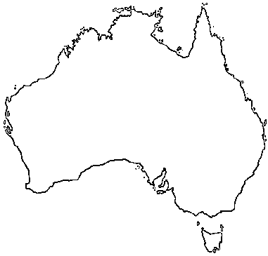
Label these features:
- Southern Ocean
- Indian Ocean
- Pacific Ocean
- Coral Sea
- Great Barrier Reef
- Great Victoria Desert
- Ayers Rock

AUSTRALIA | Location | Climate | Resources | Where People Live

Answer the following questions:
- What is destroying the Great Barrier Reef? What can be done to solve the problem?

- What is the language in Australia?

- What is the main language in Australia?

- Australia has a __________ literacy rate and a __________ standard of living.

- Who are the native people of Australia?

- Why is Australia called the “Land Down Under”?
Europe

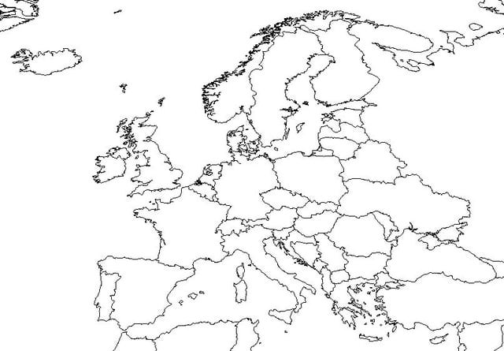
Label these countries:
- United Kingdom
- Spain
- France
- Belgium
- Germany
- Poland
- Italy
- Ukraine
- Russia

Label these physical features:
- English Channel
- Iberian Peninsula
- Scandinavian Peninsula
- Pyrenees Mountains
- Rhine River
- Danube River
- Alps
- Ural Mountains
- European Plain

 | Location | Climate | Resources | Where People Live
UK
Russia
Germany
Italy

 | Environmental Problem | Cause | Solution
Germany
United Kingdom
Ukraine

 | Example Languages | Where is it spoken?
Germanic
Romance
Slavic

 | Founder | Holy Book | Followers are…
Christianity
Judaism
Islam

