CUBAN REVOLUTION

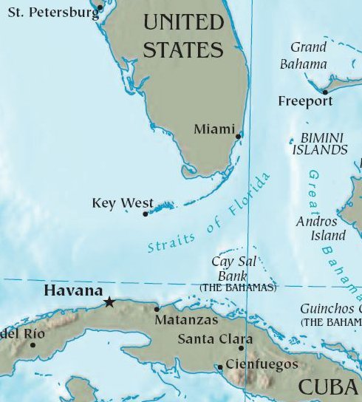
Cuba is an island nation in the Caribbean Sea, located only 90 miles south of Florida in the United States.

For most of the twentieth century (1900s), Cuba had political problems. Leaders came into power and were then overthrown by others. During this time, American businesses still did a lot of business and trade with Cuba. In fact, a large amount of Cuba’s trade with other countries was with the United States. American companies owned a large amount of land in Cuba. Most of Cuba’s sugar cane crop was sold to America.

In the late 1950s, a change in leadership took place there. Fidel Castro became dictator, creating the only communist country in the western hemisphere. Castro’s power was so strong that he ruled for nearly 50 years!

In the late 1950s, Fulgencio Batista was ruler of Cuba. He had been elected President at one time, but then made himself a dictator. That meant that he ruled the country without any controls or limits on his power. Many people in Cuba were unhappy with his rule…there was a large amount of poverty and the citizens’ education and health care were very bad!

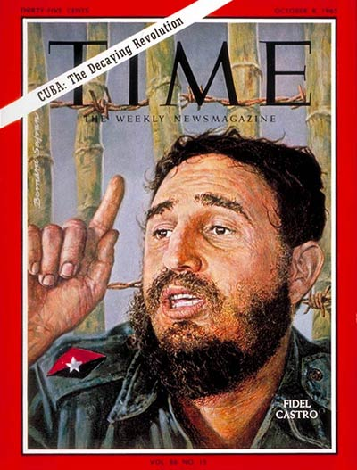
Fidel Castro led a group of rebels against Batista and because Batista was so unpopular, many Cubans followed Castro instead. Castro defeated the Batista government and made himself dictator of Cuba in 1959.

Castro began right away to organize a communist government. Communism is a political and economic system where everything is controlled by the government.

He declared that all the property belonging to Americans now belonged to the government. All farms, factories, and businesses owned by Cubans also became government property. Castro had people who supported Batista arrested. Most were executed by a firing squad, but some spent decades in prison. Cubans no longer had the right to protest against the government and all newspapers, radio, and television were shut down. The government was the only source of news. Churches were closed and all church property was taken by the government.
Because of these harsh events, the US placed an embargo on Cuban goods. An embargo is a ban on trade with a certain country. That meant that Cuba’s sugar cane crop could not be sold to the US.

The Soviet Union became friends with Cuba and they bought the country’s sugar cane crop each year. They also supplied weapons and other goods to Cuba. The Soviets helped to educate young Cubans and trained their military.

Under Castro’s rule, the Cuban people had some benefits. Hospitals and schools were improved. Women and blacks became better educated and had better jobs. However, most parts of people’s lives were controlled by the government. People who practiced their Christian religion were discriminated against. Although everyone was guaranteed a wage, the income of most Cubans was low. The country was one of the poorest in the Caribbean and was one of the least free.

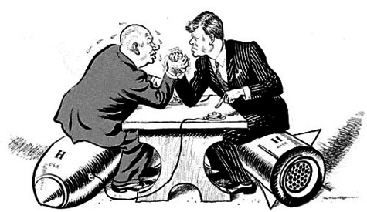
Castro’s government and the US government did not get along well. The United States did not like having a communist country so close to Florida. Americans who owned land and businesses in Cuba did not like the loss of their property. The United States decided to keep the pressure on Cuba and it did not allow travel by Americans to or from Cuba. It also tried to keep other countries from trading with the Cubans.

Cuba tried to spread communism into Latin America. It supported revolutionary ideas in many countries by providing military training, money, and weapons. One event, the Cuban Missile Crisis almost started a nuclear war. In 1962, Cuba gave the Soviet Union permission to build a missile launching complex in their country. Missiles launched from the site could reach US cities. US President John F. Kennedy demanded the missiles be removed. A tense time followed, but the Soviet Union agreed to remove the missiles and the US said it would not invade Cuba.

Relations between the US and Cuba have not improved much in the past 50 years. Fidel Castro stepped down from his role as President in 2008 and was succeeded by his brother, Raul.

In July of 2015, the United States restored diplomatic relations with Cuba for the first time since 1961. However, there is still an embargo against trade and travel with Cuba.

Describe US-Cuba relations today…

Why did the US put an embargo on Cuba?

Which European country supported Cuba?

How did Castro’s communist government change Cuba?
- Negatives:

- Positives:

Who led a rebellion and became dictator of Cuba?

Why did Cubans not like Batista’s government?

Until the 1950s, who did Cuba do most of their trade with?

Where is Cuba located?
Vocabulary

- Communism:

- Embargo:
CUBAN
REVOLUTION

