World Geography:
Continents and Oceans

Geography: the study of the _____________________ of places, the _____________ who live in a certain area, and the environment of that area.
- Physical Features: mountains, lakes, deserts, etc.
- Climate (___________________)
- Culture
- Environmental Problems

Our world has _____ continents!
- Continent: a large land mass or a large area of continuous land
The 7 continents are…

- North America
- South America
- Africa
- Europe
- Asia
- Australia
- Antarctica

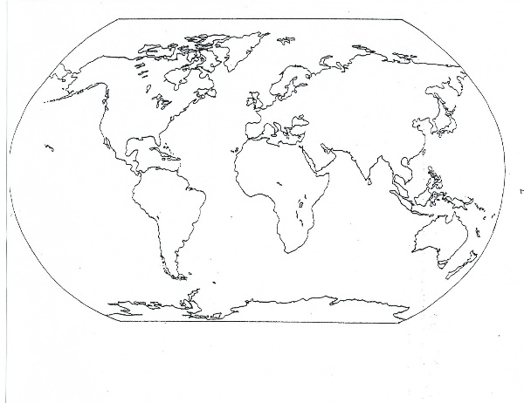
Australia
- Australia is the only country that is both a ________________ and its own continent
  - Most continents are divided into many different countries
- Australia is the ___________________ continent

Antarctica
- Antarctica is the __________________________ continent
- Surrounded by the Southern Ocean
- Only 135 residents and no official country/government

Africa
- 2nd ____________________ continent and 2nd most populated continent
- Bordered by the Atlantic Ocean, Indian Ocean and Southern Ocean

Asia
- The world’s ___________________ continent by both size and population
- Bordered by the Pacific Ocean, Indian Ocean, and Arctic Ocean

Europe
- Europe is the 2nd _____________________ continent by land size, BUT the 3rd largest by population
  - That means…a lot of people in a smaller space!
- Europe has about _______ different countries!

North America
- 3rd largest continent by land size and 4th largest by population
- Includes the countries of ______________, the United States, and Mexico
- Bordered by the Arctic Ocean, Pacific Ocean, and Atlantic Ocean

South America
- 4th largest continent by land size and 5th largest by population
- Includes _________ different countries
- Bordered by the Southern Ocean, Pacific Ocean, and Atlantic Ocean

Oceans of the World
- Our world has _______ different oceans!

  - Arctic Ocean
  - Atlantic Ocean
  - Indian Ocean
  - Pacific Ocean
  - Southern Ocean

