Name: _______________________________________ Class Period: ____

Cold War
Review

- Who were the 2 “Superpowers” in the Cold War? ________________________________________________________________________

- Which two barriers represented a division between Communism and Democracy in Europe? _________________________________________________

- Which country was reunified in 1990? __________________________________

- What collapsed in 1989? _______________________________________________

- When did the Cold War end? ___________________________________________

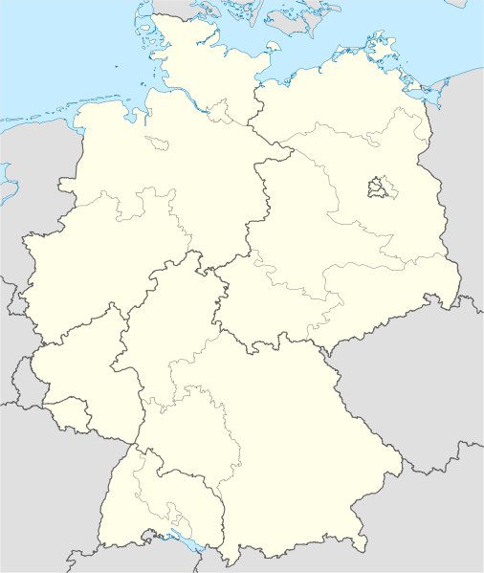
A Divided Germany

After World War II, Germany and Berlin were divided into 4 occupation zones.

Use your Cold War Reference Sheet to correctly label and color the map below.
- Label each section with the country that occupied it after World War II (Soviet Union, United States, France, and Great Britain)
- Color each section a different color then create a map key

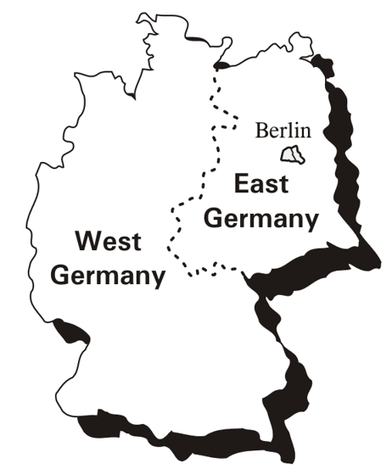
West Germany versus East Germany

In 1949, the United States, Great Britain, and France joined their zones together to form West Germany (Federal Republic of Germany). The Soviet Union kept their zone separate and created the communist country of East Germany (German Democratic Republic).

- Use a marker to go over the border between East and West Germany.
- Color democratic West Germany blue
- Color communist East Germany red

The Iron Curtain
The Iron Curtain was both a physical and ideological boundary that divided Europe from the end of World War II in 1945 to the end of the Cold War in 1991. It divided the continent into democratic countries in the West and communist countries controlled by the Soviet Union in the East.

- Use a marker to go over the line representing the Iron Curtain
- Color the land west of the Iron Curtain in blue
- Color the land east of the Iron Curtain in red

